Write flutter packades in google

And enter in pub dev url for packages.

Search engish_words generate

Open it and click on installing.

Now copy line

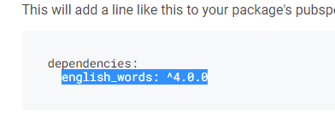

And paste it in pubspec folder under dependencies.

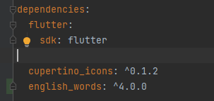

Now click pub get

After that import it in main folder

**import** 'package:english_words/english_words.dart';

now use below command to see all words.

**void** main() {

generateWordPairs().forEach(print);

}

Here is complete code:

import 'package:flutter/material.dart';  
import 'package:english_words/english_words.dart';  
  
// void main() {  
// generateWordPairs().forEach(print);  
// }  
void main() => runApp(XylophoneApp());  
  
class XylophoneApp extends StatelessWidget {  
 @override  
 Widget build(BuildContext context) {  
 return MaterialApp(  
 home: Scaffold(  
 body: SafeArea(  
 child: Text(nouns.first),  
 ),  
 ),  
 );  
 }  
}